Directions for Requesting a Sabbatical
- You will get an email that a sabbatical request has been created for you.
You can click on the link in the email, and it will take you into Interfolio, where you will see this screen. You can click on your case in the middle of the screen.
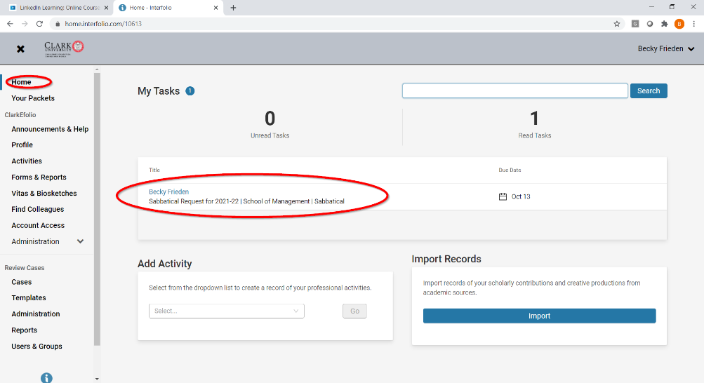
- When you click on your case name, you’ll see this page. If you want to view the instructions, click on “View Instructions.” When you’re ready, click on the “Packet” tab.
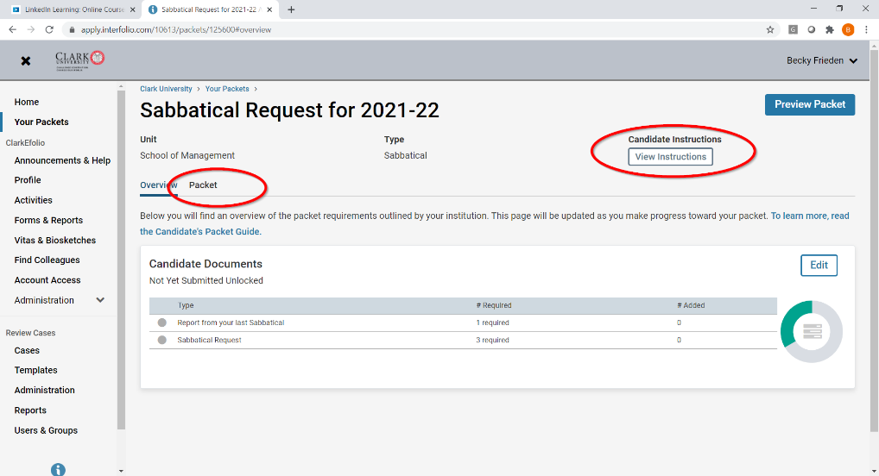

- On the “packet” tab, you’ll see this screen. The first thing you should do is upload the report from your last sabbatical. (If this is your first sabbatical request, you can skip this step and go to step # 5 below.) Click on the “add” button, and you will get a pop-up. Click on “add new file” and you will be directed to upload the file from your computer.
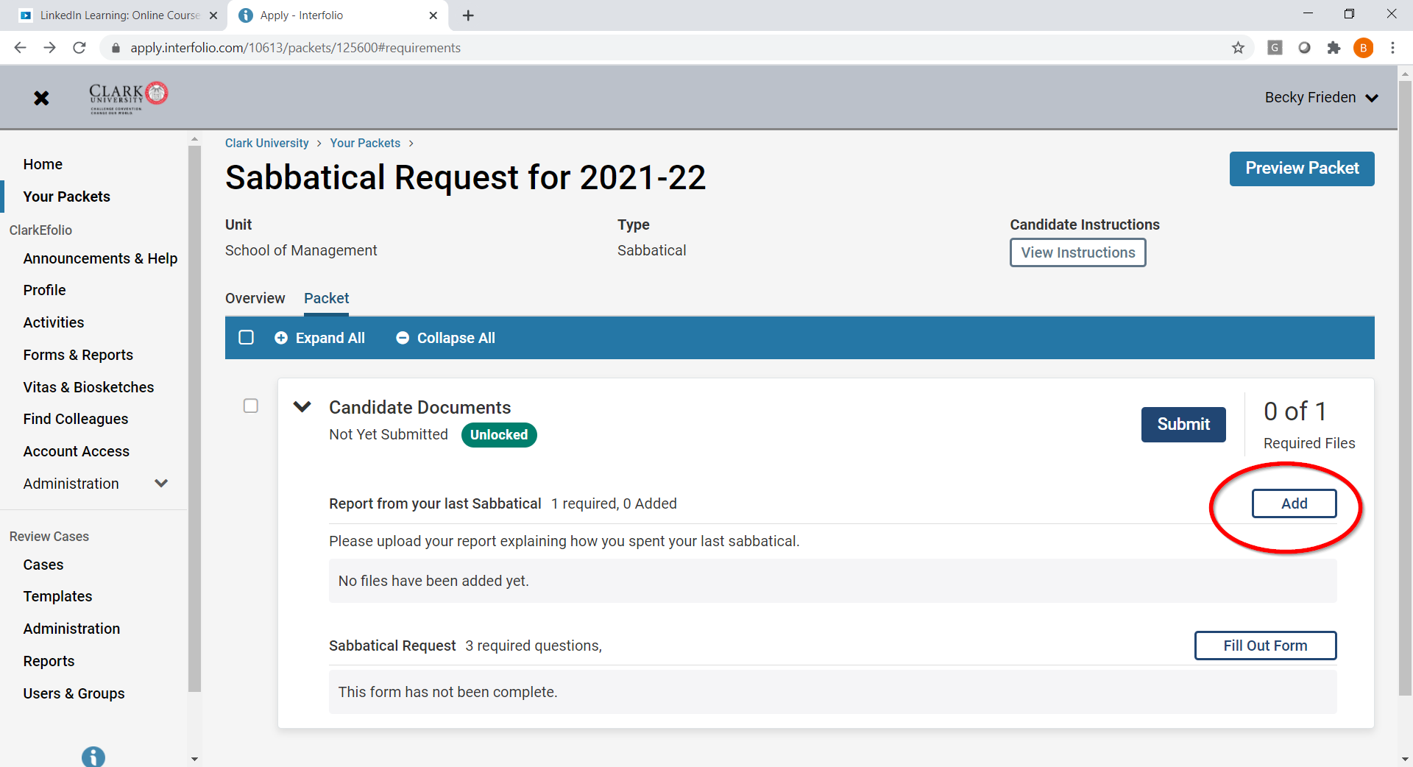
- Click on “add new file” and you will be directed to upload the file from your computer.
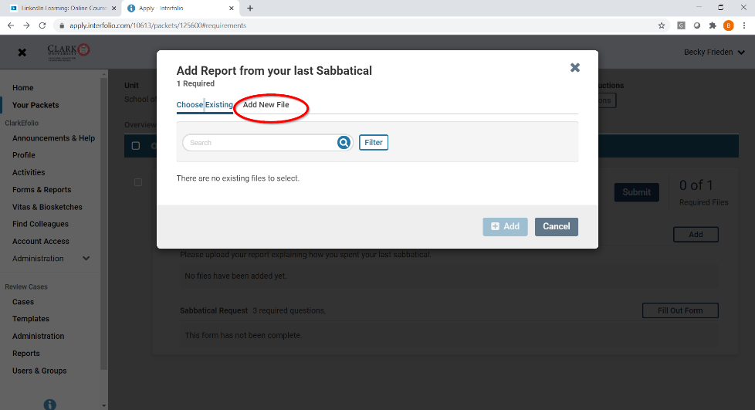
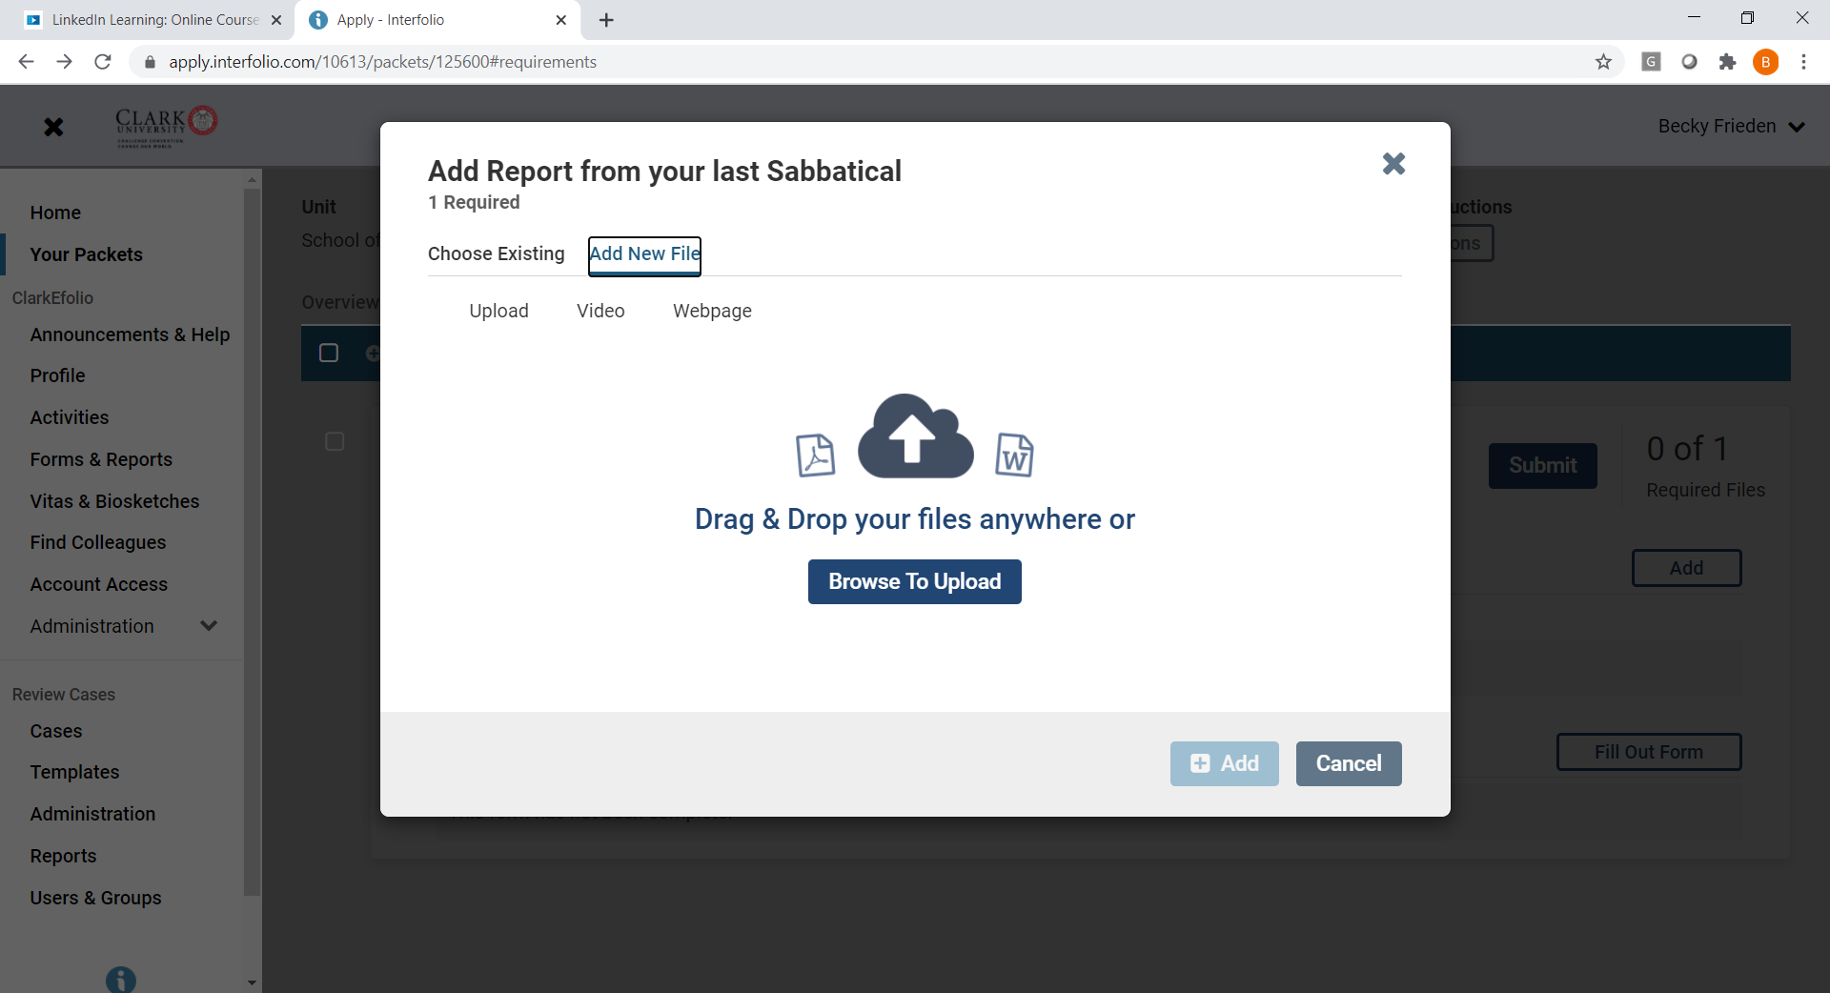

- After you upload your report, you can fill out the sabbatical request form. 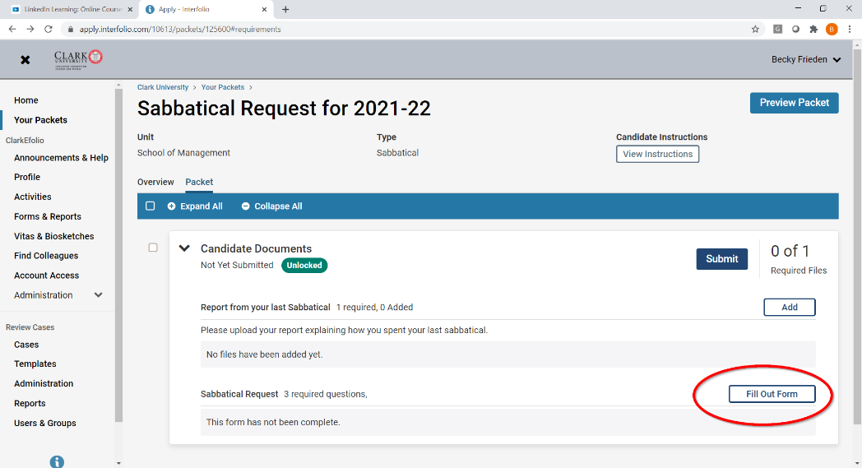
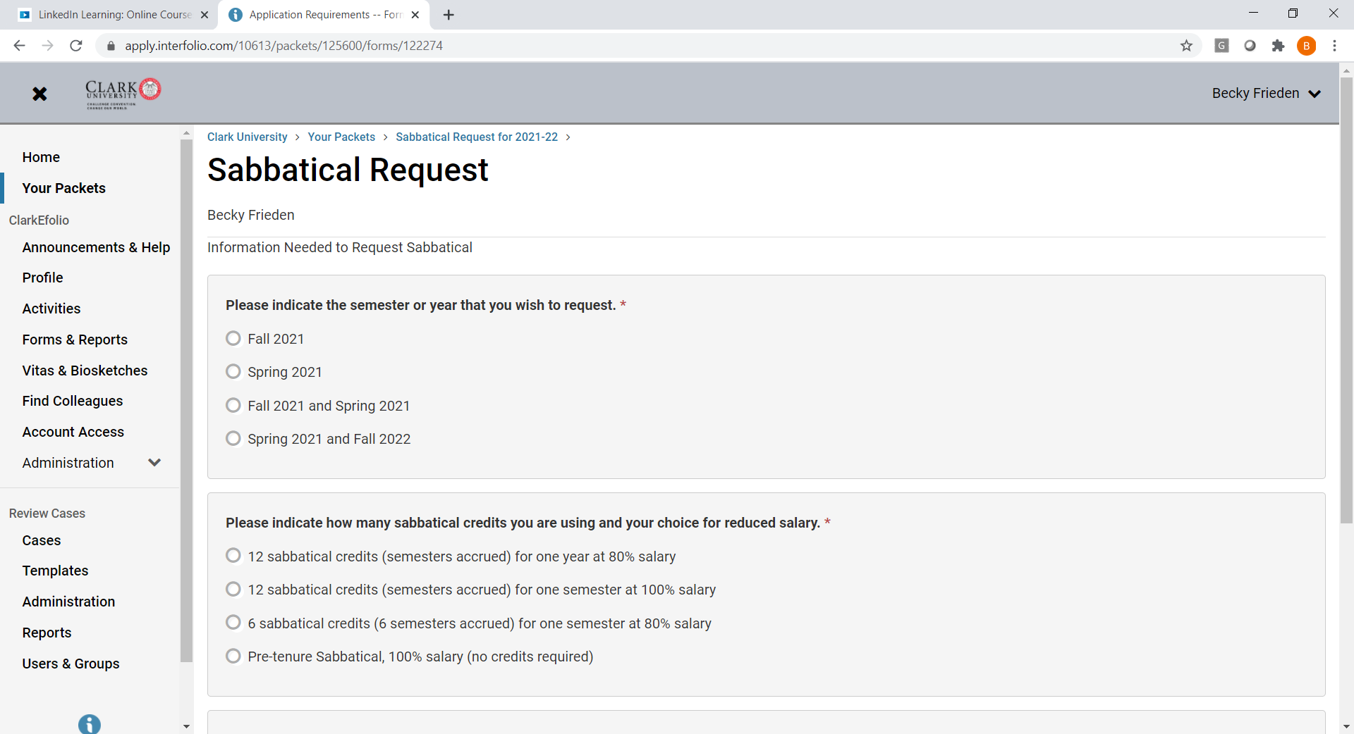
You can paste your sabbatical plans into question # 3, and then click “done.”
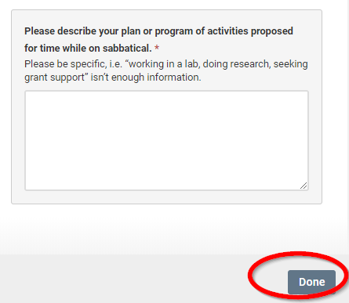
- When you’re back on the main page, you have the option to preview your packet, and then you must “submit.”

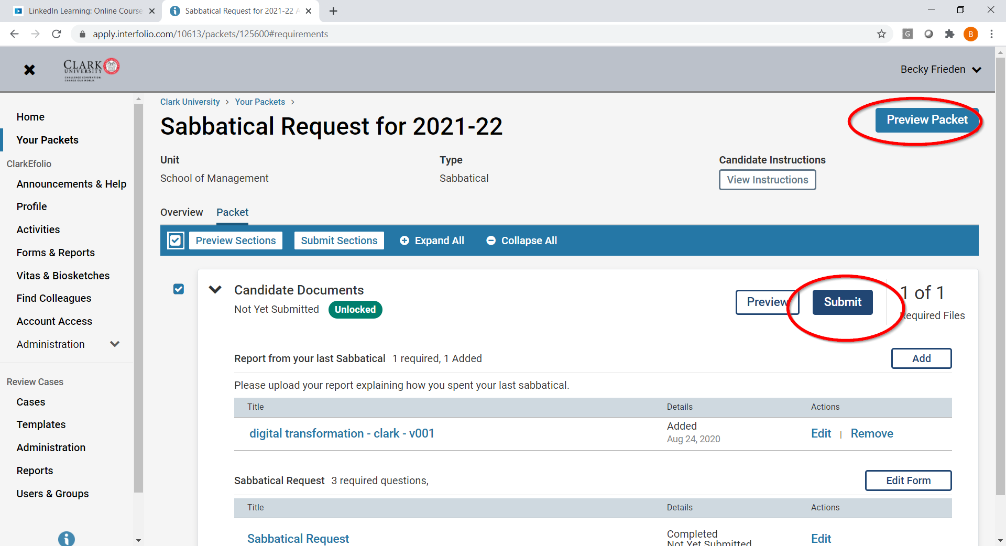
You’ll get a warning message like the one below. If you’re done, you can click the “yes” button. The case will be sent to your department chair.
